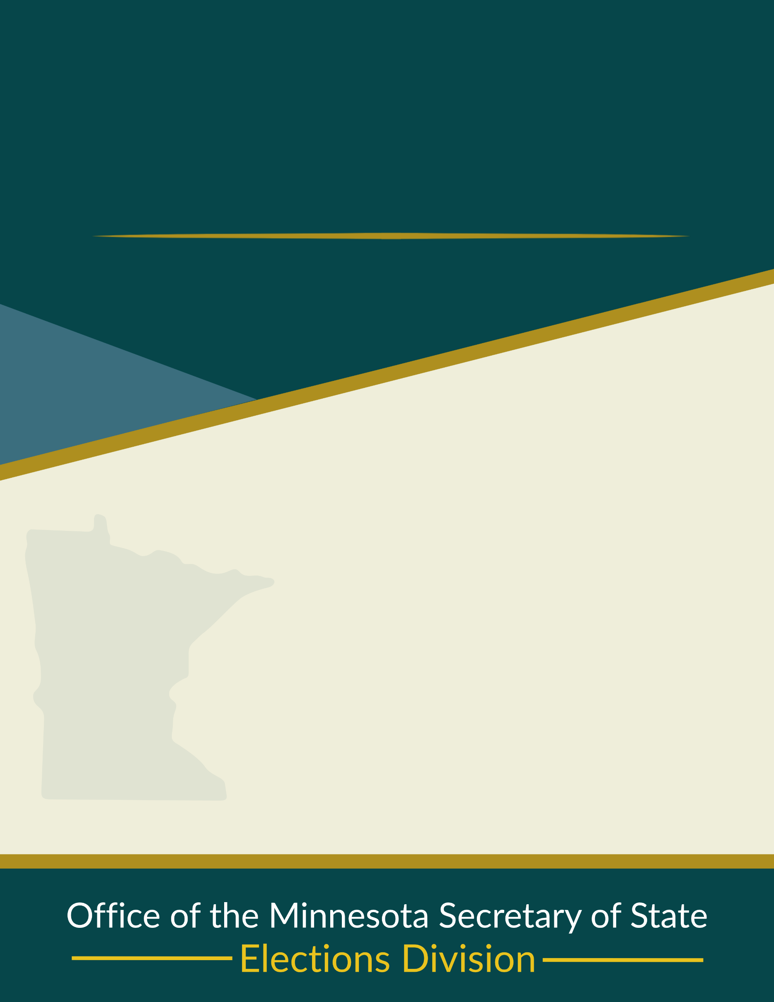
Minnesota Elections Administration
Election Judge Manual
Veterans Service Building, Suite 210
20 W 12th Street, Saint Paul, MN 55155
Phone (651) 215-1440
Toll Free 1-877-600-8683
Minnesota Relay Service 1-800-627-3529
Email elections.dept@state.mn.us
Website www.sos.mn.gov

Introduction
This manual is a reference for election judges on Election Day. Most sections include citations, referencing election laws which are noted as Minn. Stat. or election rules which are noted as Minn. Rule.
You can find the full text of these laws and rules on the Secretary of State’s Election Laws webpage (https://www.sos.mn.gov/election-administration-campaigns/election-administration/election-laws/).
Election judges serve in a nonpartisan role to ensure that elections are fair, accessible, and conducted according to law. Your work is essential to maintaining voter confidence in Minnesota’s elections.
Judges should review this manual before Election Day and bring it with you to the polling place. While you are not expected to memorize every detail, you are expected to be familiar with election procedures and to know where to look for guidance during the day.
Important: This manual is intended as a practical resource for your Election Day duties. It does not replace state law or local guidance. For local processes and procedures related to your election judge training and assignment, follow the instructions of your head judge and local election official; instructions and guidance from them will be more specific to your location and needs.
Thank you for serving as an election judge!

Contents
Introduction 2
General Information 5
Qualifications and Restrictions 5
Student Election Judge Trainees 5
Training and Certification 5
Polling Place Assignments 6
Number of Election Judges per Precinct 6
Party Balance of Election Judges 6
Election Judge Position Descriptions 7
Election Judge Descriptions 7
Conduct Expectations and Protections 8
Election Judge’s Oath 8
Code of Conduct 8
Removal of Election Judges 9
Protections 9
Preparing for Election Day 10
Time Off from Work 10
Appropriate Attire 10
Breaks and Meals 10
Remember to Vote 10
Before Leaving Home 10
Chain of Custody and Emergency Plans 11
Chain of Custody for Election Materials 11
Election Emergency Plans 11
Setting Up the Polling Place 12
Access to Polling Place 12
Posting Signs and Directions 13
Name Tags 13
Review Basic Supplies 13
Polling Place Layout and Stations 14
Equipment Setup 15
Preparing Ballots 16
Opening the Polls 17
Election Judge Activities During Voting Hours 18
Greeter Judge 18
Roster Judge 18
Registration Judge 21
Demonstration Judge 24
Ballot Judge 25
Ballot Counter Judge 26
Election Day Health Care Facility Voting 28
Ballot Board Members and/or Early Voting Officials 28
Rules for Polling Place Conduct 29
Rules for Polling Place Conduct 29
Media in the Polling Place 30
Security Practices 30
Providing Assistance to Voters 31
Serving Voters with Disabilities 32
Contesting a Voter’s Eligibility 33
Voter Complaints 35
HAVA Complaints 35
State Election Law Complaints 35

Closing Polls Procedures 37
Closing the Polls Overview 37
Keeping Ballots and Equipment Secure 37
Closing Activities Based on Counting Method 37
Completing the Summary Statement 38
Duplicating Ballots 38
Delivering Election Supplies and Ballots 38
Closing with a Central Ballot Count 39
Hand-Count Precincts 40
Head Judge 43
Health Care Facility Judges 45
Helpful Links and Resources 47
Minnesota Secretary of State Website Resources 47
Head Judge Duties Checklist 48
Voter’s Bill of Rights 50
Guide for Registration Application 51
Important Contact Information 52

General Information

Qualifications and Restrictions

Basic Qualifications
To serve as an election judge, you must:
- Be eligible to vote in Minnesota
- Be able to read, write, and speak English

Restrictions
You cannot serve as an election judge in the following situations:
- You are a candidate on the ballot in that precinct including as a write-in candidate
- You are a relative of a candidate on the ballot in that precinct
  - Types of relatives include spouse, parent, child, stepchild, sibling, stepsibling
  - The word “in-law” is not listed in the statute
- You live in the same household as a candidate on the ballot in that precinct
- You are related to another judge working in the same precinct at the same time
  - Relatives may work separate, non-overlapping shifts
- You are serving as a challenger to contest voter eligibility
Minn. Stat. 204B.19; Minn. Stat. 204C.07, subd. 4

Student Election Judge Trainees
Students aged 16 and 17 can serve as election judge trainees without party affiliation. They must:
- Be U.S. citizens
- Be in good academic standing at a Minnesota high school
- Have permission from a parent/guardian and their school
- Serve in their county or an adjacent county
Trainees are paid at least two-thirds of the minimum wage, work set hours, and do the same tasks as other judges, except those requiring party affiliation. They must complete the same training as other judges. A student who starts as a trainee before turning 18 can continue in that role after graduation until they turn 18.
Minn. Stat. 204B.19, subd. 6; Minn. Stat. 204B.22, subd. 4; Minn. Rule 8240.1655, subp. 3

Training and Certification
You must complete election judge training before serving.

Training
- is at least two hours long
- is valid for two years
- must be repeated every two years to stay certified
Head Judges and Health Care Facility Judges must complete an extra hour of training. Judges on absentee ballot boards must also complete additional training.

Certification
Local election officials must keep proof of training on file.
Minn. Stat. 203B.121; Minn. Stat. 204B.25; Minn. Rule 8240.1750; Minn. Rule 8240.2100

Polling Place Assignments
You will likely be assigned to work in or near your home precinct, though local officials may place you elsewhere. Judges are appointed at least 25 days before the election (unless more are needed later). Except for the Head Judge, you may work all or part of Election Day, based on local needs.
Minn. Stat. 204B.21; Minn. Stat. 204B.22, subd. 1(b)

Number of Election Judges per Precinct
- In state general elections:
  - Precincts with more than 500 registered voters must have at least four judges
  - Precincts with 500 or fewer registered voters must have at least three judges
- In all other elections, each precinct must have at least three judges
- At least two judges must represent different major political parties, and no more than half can be from the same party
- Party affiliation rules do not apply to student trainees or to judges in school district or township elections not held with a statewide election
- Judges who are not affiliated with a major political party must submit a signed statement saying so to their appointing authority
- Trainees cannot make up more than one-third of the judges in a precinct and do not count toward the minimum number of judges
Minn. Stat. 204B.21, subd. 2; Minn. Stat. 204B.22; Minn. Stat. 204B.19, subd. 5

Party Balance of Election Judges
Political party balance for election judges:
- No more than half (or half plus one) of the election judges may be from the same major political party in any location where ballots are being counted as per Minn. Stat. 204B.19, subd. 5.
- Each major political party must be represented by at least one election judge in every precinct as per Minn. Stat. 204B.19, subd. 5.
Note: This requirement does not apply to school district or township elections that are not held with a statewide election.

Election Judge Position Descriptions
The positions below are commonly used at polling places. Some jurisdictions may use different titles. Some roles are optional such as Greeter Judge, and others can be combined such as Demonstration and Ballot Judge. The Head Judge may assign or rotate judges between positions throughout the day. These are general overviews, more detailed information about roles and responsibilities are provided later in this manual.

Election Judge Descriptions

Polling Place Judges

Head Judge
Leads and manages the polling place. Requires additional training. Reviews credentials of challengers, media, and election administration representatives to decide if they may remain in the polling place. May conduct challenge procedures.

Greeter Judge
Directs traffic flow and maintains order. Monitors curbside voting area and alerts other judges when a vehicle is present. Provides information to voters about their correct polling place and registration requirements. Answers questions about language or disability assistance.

Roster or Electronic Roster Judge
Signs in voters who registered before Election Day. Alerts voters to any record notations such as A.B., challenges, or “see ID”.

Registration Judge
Registers voters who did not register before Election Day and refers voters to their correct polling place if needed. The election judge who registers or updates a voter’s registration on Election Day must not handle that voter’s ballots at any time before the ballot box is opened after voting ends. In precincts with electronic rosters, this role may be combined with the roster judge role. Registration judges may also conduct challenge procedures.

Demonstration Judge
Shows voters how to mark and cast a ballot.

Ballot Judge
Issues official ballots to voters. Explains how to handle spoiled ballots. Monitors and maintains the supply of ballots and secrecy covers.

Ballot Counter Judge
Oversees the ballot box area and gives out “I Voted” stickers. Maintains physical security of the ballot box by ensuring all compartments and doors remain locked during voting. Ensures the equipment’s paper tapes are not tampered with. Immediately reports any security concerns to the Head Judge, who may relay them to the county or municipal office.

Other Election Judges

Health Care Facility Absentee Ballot Judge
Delivers ballots to voters in health care facilities or hospitals. Requires additional training.

Absentee Ballot Board Judge
Serves on a board that processes absentee ballots. Requires additional training.

Early Voting Official
Serves as staff at an Early Voting location.

Conduct Expectations and Protections

Election Judge’s Oath
Before serving, each election judge must take and sign the oath required by law.
By taking this oath, you agree to uphold election laws and serve voters fairly and impartially. “I .......... solemnly swear (or affirm) that:
(1) I will perform the duties of election judge according to law and the best of my ability and will diligently endeavor to prevent fraud, deceit and abuse in conducting this election.
(2) I will perform my duties in a fair and impartial manner and not attempt to create an advantage for my party or for any candidate.
(3) I will not share information about voting that I know to be materially false and will not intentionally hinder, interfere with, or prevent a person from voting, registering to vote, or aiding another person in casting a ballot or registering to vote, except as specifically required by law.”
After all judges have taken and signed the oath, attach the signed oath to the precinct summary statement of election returns. If no person who is authorized to administer oaths is present, the election judges may administer the oath to each other.
Minn. Stat. 204B.24; Minn. Stat. 204B.26

Code of Conduct
While serving, set aside personal opinions and focus on supporting a fair election. On Election Day, your role is to follow election laws and procedures to the best of your ability.
You must:
- Always remain courteous and professional
- Do not bully or harass local election officials, Head Judges, other election judges, challengers, media, election administration representatives, vouchers, voters, or voter assistants
- Follow all instructions and complete all assignments given to you by the Head Judge
- Keep the Head Judge informed of all concerns and document details on incident logs
- Refrain from partisan comments or discussions
- Do not discuss the decisions and/or actions of political leaders
- Refrain from personal opinions of current election administration laws, rules, procedures and/or tasks
- Except to verify party balance, do not disclose or use for any other purpose the party affiliation or unaffiliated status of other election judges
- Avoid any action that may influence how a person votes
- Respect a voter’s right to use the lawful assistance of any eligible person of their choice
- Provide respectful assistance to persons with language and/or disability challenges
- Keep passwords or other access credentials for voting equipment in a safe and secure location.
- Respect the secret ballot and the privacy of voters:
  - Do not give advice, scrutinize ballots, or reveal how people voted
  - Never disclose personal information about voters found on the polling place roster.
    - For example, a voter’s birth date
  - Conceal or hide a “challenge” status notation of voters from the view of other voters
Minn. Stat. 204B.19, subd. 5; Minn. Stat. 204B.21, subd. 3; Minn. Stat. 204B.24; Minn. Stat. 204C.10(e);
Minn. Stat. 204C.15, subd. 1

Removal of Election Judges
Local election officials, such as the county auditor or municipal clerk, may remove any election judge at any time if the judge:
- fails to fulfill required duties
- commits misconduct
- or for any other valid reason under state law
Serving in violation of Minn. Stat. 204B.19 through 204B.25 is a misdemeanor under state law.
Minn. Stat. 204B.26

Protections

Protections for Voters
State law prohibits anyone from intimidating, deceiving, or interfering with voters.
This includes:
- Threatening or using force, harm, or economic pressure to influence how someone votes or whether they vote
- Spreading false information about the election, such as when, where, or how to vote, within 60 days of an election, if intended to stop someone from voting
- Blocking, interfering with, or preventing someone from registering or voting
- Helping, directing, or conspiring with others to intimidate or interfere with voters
Violations are punishable as gross misdemeanors.
The attorney general, county attorneys, or people harmed by a violation can also file civil actions for penalties or damages.
Minn. Stat. 211B.075

Protections for Election Judges and Other Election Officials
State law also protects election officials, including election judges, from threats or interference.
It is illegal to:
- Threaten or intimidate an election official to influence their work
- Interfere with or prevent an election official from doing their duties
- Publicly post an election official’s home address or personal details if it could pose a serious safety threat
- Block an election official’s physical access to their work site
- Tamper with voting equipment, ballot boxes, or election systems
- Alter or destroy voter registration records or polling place rosters
- Access the Statewide Voter Registration System without authorization
- Help or conspire with others to commit any of these acts
Violations are gross misdemeanors.
Civil actions may also be brought by the attorney general, county attorneys, or affected election officials.
Minn. Stat. 211B.076

Preparing for Election Day

Time Off from Work
State law allows you to receive time off from work to serve as an election judge. The jurisdiction hiring you will provide a form with your scheduled hours and pay rate. Notify your employer in writing at least 20 days in advance and attach a copy of your schedule and pay rate form. Minn. Stat. 204B.195
Employers may:
- Limit the number of employees absent to serve as election judges to 20 percent of the workforce at a single worksite
- Reduce your salary or wages by the amount you are paid as an election judge during work hours
Example: If you normally work 8 hours at $25 per hour ($200 total) and are paid $17 per hour as an election judge, your employer can reduce your regular pay by $136 (8 × $17) and pay you the remaining $64.
You may also choose to use vacation time and keep your full regular pay while receiving election judge pay as extra income. Employers cannot require you to use vacation time.
Note: Minn. Stat. 204B.195 applies to employees of Minnesota employers, voters who are federal employees or work outside of Minnesota should check with their HR department to see if this law applies to them.

Appropriate Attire
Dress comfortably and casually. Like voters, you cannot wear political or campaign-related attire. You may bring your own personal protective equipment (PPE) for health purposes, such as masks or gloves.

Breaks and Meals
You may bring food for the day, including breakfast, lunch, snacks, and dinner. The Head Judge will arrange breaks and mealtimes. Contact your Head Judge before Election Day with any questions about meals and breaks.

Remember to Vote
If you are working in your own precinct, you may vote during a break on Election Day or vote absentee before Election Day.
If you are serving in a different precinct, vote absentee before Election Day.
For information on how to vote absentee, visit the Minnesota Voter Information webpage (see Other Ways to Vote). Minn. Stat. 204C.04
Employees also have the right to be absent from work to go to their polling place, vote, and return to work during the absentee voting period. This applies to regularly scheduled elections and some federal and state special elections.

Before Leaving Home
Election Day will be a long day. Before leaving home, check that you have everything you need for the day, including:
- Reading glasses, medications, or medical supplies
- Emergency information that coworkers should know about
- Care arranged for loved ones or pets
- Enough gas or a ride home, since you may be done late in the evening (polls close at 8 p.m. and there are closing duties afterward

Chain of Custody and Emergency Plans

Chain of Custody for Election Materials
Minnesota law requires counties and certain local jurisdictions that administer elections to maintain a chain-of-custody plan for election materials. These plans describe how ballots, voting equipment, and other election materials must be secured, documented, and transferred during an election.
Election judges must follow the chain-of-custody procedures provided by their local election official.
Election judges may assist with chain-of-custody procedures by:
- Ensuring ballots, voting equipment, and election materials remain secure
- Following instructions for sealing or securing ballot containers or equipment
- Documenting the transfer of election materials when required
Maintaining supervision of election materials when they are moved or transported Minn. Stat. 204B.182

Election Emergency Plans
Emergency events may occur on or before Election Day that affect voting operations. County and municipal election officials maintain emergency plans, and election judges must be prepared to follow them.
During emergencies such as severe weather, public health situations, civil disturbances, or other disruptions, election judges must follow lawful instructions from local election officials, the Office of the Secretary of State, and emergency personnel.

Examples of emergency plans include:
- Moving or combining polling places
- Accommodating voters with disabilities
- Protecting ballot and voting equipment security
- Extending polling place hours if voting was interrupted

If an Emergency Occurs
The immediate safety of voters and election judges is the first priority.
Take reasonable steps to ensure safety, such as:
- Taking shelter
- Evacuating the building if necessary
- Calling 911 for a medical or public safety emergency

Once immediate safety concerns are addressed:
- Notify the head judge and/or the local election official
- Follow instructions from election officials or emergency personnel
Important: Voting operations should continue as scheduled unless directed otherwise by the local election official or other lawful authority.

If a Polling Place Must Change
If an emergency requires relocating or combining a polling place, the change must be directed by and coordinated with the local election official.
- Election judges must not relocate a polling place on their own. Follow instructions from the local election official and assist as directed.

Election judges may be asked to assist with the following:
- Posting notice at the original polling place showing the new location and directions
- Ensuring voting equipment, ballots, and election materials are moved according to the chain-of-custody plan
- Helping ensure ballots and voting equipment remain secure during the move
- Providing directions to voters who arrive at the original polling place

Setting Up the Polling Place
Voting occurs in all types of buildings. You might arrive to find a space that needs substantial rearranging to make it usable. You may have only one hour to set up, so work efficiently. When setting up, focus on access, traffic flow, and privacy to ensure voters have a positive experience.

Access to Polling Place
You are required by law to make sure voters of differing physical abilities can get into and move about the polling place.
Minn. Stat. 204B.16; Minn. Stat. 204C.08
As you set up, put yourself in the position of someone who has never been to the building and has difficulty with mobility. If the voting room is within a large building with many rooms, is not on the main floor, or is a considerable distance from entrances, ask yourself:
- Is there a clear path of travel through all parts of the polling place building? Are there signs directing voters from entrances to the voting room?
- If an elevator is required to access the voting room, is it working?
- What signs will voters need to direct them from the parking lot to the appropriate polling place entrance(s)?
- Are the polling place entrance(s) unlocked and free of any barriers?
- Is the national flag displayed at the entrance of the polling place?
If any problem with access to or within the building, polling place, or voting room is discovered, it must be addressed and resolved as soon as possible. Document steps taken to address and resolve the problem on the incident log.

Traffic Flow within Voting Room
- Voters move from one station to the next in order. Arrange the voting room to support a clear, forward flow of traffic.
- Make sure there is a clear path of travel through all parts of the voting room. Remove or secure cords, rugs, or other items that could create tripping hazards or make movement difficult.
- An efficient layout will help you manage large crowds and reduce confusion.
- For line management, voter privacy, and safety, you may need to limit the number of people inside the voting room at one time.

Voting Privacy
Arrange the voting stations with privacy in mind. Others nearby should not be able to see how someone is marking their ballot. Provide voters using a table-height booth or a ballot-marking device with the same level of privacy as others.
Minn. Stat. 204C.17; Minn. Rule 8230.0250
Note: Voters are not required to use a voting station or booth to vote their ballot. If they do not want to wait for a voting station to become available, offer them other areas within the voting room (such as a built-in countertop) that offer some level of privacy. It is the voter’s choice of where they would like to vote the ballot within the voting room.

Posting Signs and Directions
Your materials will include several informational posters. Display all signs in clear view.
Minn. Stat. 204B.27, subd. 3; 204B.295; 204C.06; 204C.08; Minn. Rule 8200.5800
- Post the voting hours sign on the main entrance where voters will enter
- Verify that the sample ballot posters match the offices and questions listed on the official precinct ballots. Post at least two sample ballots that voters can study while in line. One of the sample ballots should be placed at a height that can be easily read by a person seated in a wheelchair
- Prominently display the Voters’ Bill of Rights
- If voters must walk through the building to enter the voting location, put up signs pointing the way. If the exit is different from the entrance, clearly label the exit
- Ensure parking spots for disabled voters are marked and available. Use signs from your supplies to mark new or additional accessible parking spots near the polling place entrance during voting hours
- If signs are available, use them to mark parking spots reserved for curbside voting
- Mark the entrance that voters with disabilities can use. If it is not the main door, post easily visible signs pointing the way to the accessible entrance. If voters with disabilities must take a different route to avoid stairs, post signs for that accessible route
- Post voting instructions and sample ballots in other languages in a conspicuous location in the polling place
- Place a U.S. flag at the entrance of the polling place during voting hours
At various times during voting hours, double-check that all posters and signs are in place and not damaged or defaced. If needed, replace or repair posters and signs and document the incident(s) on the incident log.

Name Tags
Wear an identification badge or sticker identifying your role, such as Head Judge, Judge, or Trainee Judge. Badges cannot state a party affiliation. If an election judge provides interpretation services, list the language(s) after the judge title. Minn. Stat. 204C.06, subd. 2(c)

Review Basic Supplies
Polling place supplies vary across the state. If you believe supplies are missing or in short supply, call your local election official.
If official ballots are not present at the time voting begins, or if the supply runs out before voting ends, contact your election official immediately. Under their direction, election judges must prepare unofficial ballots so there is no delay in voting. Voters may use unofficial ballots until official ballots are available.
Minn. Stat. 204B.29; 204B.30; 204C.06, subd. 3(b); Minn. Rule 8230.0570; 8230.0580
Supplies may include:

- National flag
- Election judge guides
- Polling place signs and sample ballots for display
- Election-specific polling place signs (PNP, primary)
- Voting booths and/or privacy screens
- Ballot counter and ballot box
- Ballot marking device (may be attached to the ballot counter in some precincts)
- Polling place rosters / electronic pollbooks
- Magnifying glasses or signature guides
- “I Voted” stickers
- Cleaning items (surface wipes, spray cleaner)
- Line management tools (tape, stanchions)
- Greeter lists
- Precinct finder and precinct map
- Election Day voter registration applications
- Ballots
- Ballot secrecy covers
- Voting pens
- Voter receipts
- Name tags
- Election Day forms
  - Write-in tally sheets
  - Summary statements
  - Incident log
  - Election Day voter registration applications
- Curbside voting forms
- HAVA and State Election Law complaint forms
- Election Day administrative envelopes
- Voted ballot storage boxes and security seals
- Extra rolls of results paper
- Extra ink for voting equipment

Polling Place Layout and Stations
You must set up several stations on Election Day. Make sure access to each station is clear of physical obstacles.

Outside of the Polling Place
- Place the national flag by the entrance door(s) closest to the voting room.
- Place accessible parking signs for spaces near the entrance.
- Mark additional parking spaces for curbside voting.

Voting Line and Voting Room Chairs
Minnesota law requires judges to provide chairs for voters with limited mobility to sit on while waiting in line, receiving instructions, or marking their ballot.

Example Polling Place Layout
Minn. Stat. 206.90, subd. 7; Minn. Stat. 204B.18, subd. 1(d)
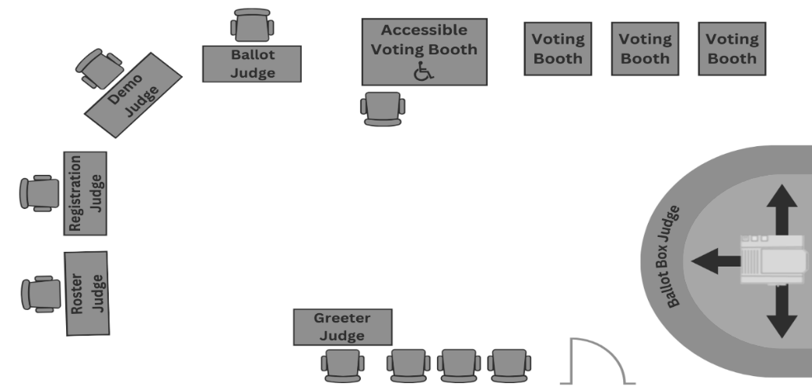

Roster Judge Station
- You may need more than one table
- Place paper rosters, if used, and pens on the table
- Display alphabet signs high enough for voters to see from the end of the line
- Place magnifying glasses and signature guides on the table, if available
- Place voter receipts and curbside voting forms at the station
- If challengers are present, provide chairs nearby
- If using electronic rosters, turn them on, verify they are charged, and plug them in if possible

Registration Judge Station
- Provide a stable, flat writing surface for voters completing Election Day registration forms
- Place the registration roster, forms, voter receipts, and needed supplies on the table

Demonstration Judge Station
- Prepare demonstration ballots, pens, and instructions showing how to mark a ballot

Ballot Judge Station
- Often combined with the Demonstration Judge Station
- Place official ballots, demonstration ballots, pens and the spoiled ballot administrative envelope at the table
- Confirm where voter receipts will be stored
  - Examples include spindle, container, or envelope

Voting Booth Stations
- Arrange booths for privacy so voters can mark ballots in secret
- At least one booth must be at table height with a chair, accessible to voters using wheelchairs
- Place instructions in each booth on how to mark the ballot
- Check that booth lighting works and is adequate
- Place a pen or marking device suitable for the voting equipment in each booth

Ballot Marking Assistive Voting Device Station
- If separate from the ballot counter, place the device on a chair-height table with a sturdy chair
- Provide as much privacy as possible
- Confirm the device is turned on, plugged in, and the outlet has power

Ballot Counter and Ballot Box Station
- Confirm the ballot counter is turned on, plugged in, and the outlet has power
- Verify the program stick or card storage compartments are locked
- Ensure paper reports/tapes are secured and cannot be torn or tampered with
- Only voters casting ballots and election judges may be within six feet of the ballot box. Mark the six-foot boundary with tape if possible
- Place “I Voted” stickers at this station
  - Hand them to voters or point to where they are located, but do not place them on voters

Equipment Setup
Most precincts will have two pieces of equipment to set up: a ballot marking device and a ballot counter.
Confirm that both pieces of voting equipment are working before completing other opening duties. If they do not work properly, or if there are questions, ask the Head Judge to contact the local election official immediately. Minn. Stat. 204B.18

Ballot Marking Device
Except for stand-alone township elections in townships with fewer than 500 registered voters, ballot-marking devices must be present in every polling place. Some ballot markers connect directly to the ballot counter; others are separate devices. Minn. Stat. 206.84, subd. 6; Minn. Stat. 206.57, subds. 5 & 5a

Setup steps:
- Set up the station
- Place the device on a chair-height table in a location that offers voter privacy.
- Plug the device into an electrical outlet. Use an extension cord if needed.
- Include a sturdy chair at the table. The station must be usable by either a voter in a chair or a voter using a wheelchair.
- Place the station where it will not be confused with the ballot counter, and ensure the path is wheelchair accessible.
- Face the screen toward a wall or other private area so only the voter can see it.
- Test the device
Insert a test ballot and verify that all offices and candidates appear correctly on the screen and through the headphones.
- Store headphones safely
Unplug headphones when not in use.
- Follow local instructions
Follow any additional setup steps provided by your local election officials.

Precinct Ballot Counter Setup
Most precincts have a ballot counter (also called a tabulator) that reads ballots and stores vote totals for reporting after the polls close. A small number of precincts either hand count ballots at the polling place or send the voted ballots to a central location for counting by a central count ballot tabulator after the polls close. Minn. Stat. 204C.09, subd. 1
Passwords used to access voting equipment must be kept in a safe and secure location within the polling place and must not be accessible to the public. Follow instructions from your local election official regarding how passwords are stored and accessed.
The ballot counter sits on top of the ballot box. When a voter inserts their ballot, the machine reads the votes and feeds the ballot into the box. Ballot boxes have two compartments:
- a main compartment for ballots accepted by the counter
- an auxiliary compartment for ballots if the counter stops working
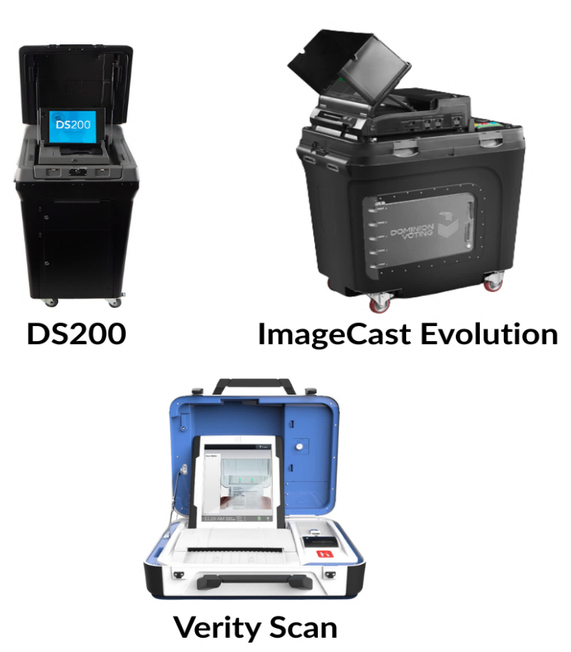
Setup steps:
- Verify the memory stick or card seal is intact.
Inspect the seal on the memory card (which stores vote totals) for tampering. Check seals, the memory card, and related data ports; types of seals vary.
- Verify that the ballot box is empty.
Remove any supplies stored inside before Election Day.
- Lock the ballot counter to the ballot box and turn on.
Some counters may arrive already sealed; if so, verify and record the seal number.
- Print and review a zero totals tape.
Confirm the offices and candidates listed on the zero tape match the ballots.
Contact your election official if there are any discrepancies.
- Keep the zero tape intact.
Secure the zero tape according to your local procedures. Methods for displaying or storing the zero tape may vary, but it must be preserved and retained with the official election materials at the end of the day.

Special Instructions for Hand Count or Central Count Precincts
In hand count or central count precincts, one judge locks the ballot box and gives the key to another judge. The box remains locked all day until ballots are either hand counted or transported to a central count location.

Preparing Ballots
- Certify the total number of ballots delivered.
Count packets (usually in bundles of 25, 50, or 100) and record totals on the provided form.
- Confirm ballots match the ballot counter programming.
If multiple ballot styles are used, confirm and set out a supply of each.
- Count ballots in each packet.
Carefully count ballots as packets are opened and fan or separate them to ensure none are stuck together. Record any discrepancies on the incident log.
- Initial each ballot.
Two judges must initial each ballot to be issued to voters. Judges from different parties are not required.
- Open ballot packs only as needed.
Keep unopened ballots secure. Notify the Head Judge if supplies run low.
- Prepare secrecy covers.
Secrecy covers are offered to voters to conceal their choices while moving through the polling place. Use is optional, but these should be made available to voters.
Minn. Stat. 204C.09, subd. 1

Opening the Polls
When opening time arrives, announce: “The polls are open.”
Generally, voting hours are from 7:00 a.m. to 8:00 p.m.
- Your local election official will notify you in advance if voting hours will be different in your precinct.
Minn. Stat. 204C.05

Open Polls Regardless of Equipment Failure
If the ballot counter or other voting equipment stops working, have an election judge call your local election official and follow these instructions:
- Do not delay voting. Do not keep voters waiting while you try to fix the equipment. Open the auxiliary compartment slot of the ballot box so voters can deposit their ballot directly into the locked box. These ballots will be processed later.
- Explain to voters that once the ballot counter is operating again, election judges will run the ballots through the counter.
- Ballot marking devices may still be used to help voters mark their ballots accurately. These devices prevent mistakes such as overvotes.
- When the equipment is working again, two election judges must remove the ballots from the auxiliary compartment and feed them into the ballot counter.
Minn. Stat. 206.57; Minn. Rule 8230.4365

Election Judge Activities During Voting Hours

Greeter Judge
As a Greeter Judge, you help direct the flow of voters and support other duties as assigned. You observe activity near the entrance of the polling place, ensure unauthorized individuals are not lingering, and confirm that campaigning is not taking place.

Your duties include:
- Welcoming and guiding voters to the appropriate stations

If Using Paper Rosters
- Direct voters to either the Pre-Registered or Registration table
- Use your Greeter’s List (showing all pre-registered voters in the precinct) to check if arriving voters are registered
- If a voter is not on the list and needs to register:
  - Use the precinct finder to confirm they are in the correct polling place
  - Explain the authorized proofs of residence they will need
  - Direct them to the registration table
- If a voter is at the wrong polling place:
  - Refer them to the correct location, providing the address and directions
  - Remind them that voting ends at 8:00 p.m. and they must be in line by that time to vote

If Using Electronic Rosters
- Direct voters to the check-in station
- Use your paper Greeter’s List (even with electronic rosters) to check if arriving voters are registered
- If a voter is not on the list and needs to register:
  - Use the precinct finder to confirm they are in the correct polling place
  - Explain the authorized proofs of residence they will need
  - Ask them to gather their documents before arriving at a check-in station
- If a voter is at the wrong polling place:
  - Refer them to the correct location, providing the address and directions
  - Remind them that voting ends at 8 p.m. and they must be in line by that time to vote
Provide chairs for voters.
Offer chairs to voters who need to sit while waiting to vote or while marking their ballot. Also provide a flat writing surface for completing forms.
Greet authorized polling place visitors.
Welcome visitors such as media or election observers and direct them to the Head Judge.
Minn. Stat. 204B.18, subd. 1(d)

Roster Judge
As a Roster Judge, you sign in voters who are already registered. If there are enough judges and paper rosters are being used, divide the roster into alphabetical sections, such as A–L and M–Z, to speed up the process. Use signs provided or make signs if needed so voters can easily see where to go.
If electronic rosters are used, follow instructions provided by local election officials. Confirm sufficient battery power and locate required paper backup rosters and supplemental reports. Paper backup rosters may only be used if given permission by your local official.
Minn. Stat. 204C.10

Checking In Pre-Registered Voters
  - Ask for the voter’s name and address.
- Do not ask a voter to look at the roster themselves to locate their name.
- If the voter had a name change or moved to a new address, they must re-register at the Registration Table, if using paper rosters, or follow the re-registration instructions on the electronic roster.
- A voter may choose to hand you an ID to assist with locating their name, especially if the spelling is difficult. This is the voter’s choice and is not required. If other voters express concerns, explain that showing ID is optional.
  - Check for roster notations. If you see a notation next to their name, refer to the Roster Notations section.
  - Point to the oath and have them sign next to their name.
- By signing, the voter affirms the oath of eligibility.
- In precincts using electronic rosters, the local election official may have the roster programmed to display the oath on the screen. The voter will sign electronically, and the oath and voter’s signature are printed on the voter receipt.
  - Give the voter a voter receipt and direct them to the Demonstration and Ballot Judge Table.
- The voter needs a receipt to get a ballot from the Ballot Judge.
- If your precinct has multiple school districts with separate ballots, note the voter’s school district on the receipt so the Ballot Judge gives the correct ballot.
- Note party preference on the receipt if it is a presidential nomination primary election.

Voters Who Have Difficulty Signing the Roster
A voter who cannot sign their name can make a mark, use a stamp facsimile, or request that another person write the voter’s name in their presence. If another person writes the voter’s name, that person must also sign their own name. If a voter signs with a mark, the election judge must certify the mark by signing the voter’s name for them. Minn. Stat. 201.056

Voter Receipts
Roster and Registration Judges issue voter receipts. Each receipt represents a signature on the roster. Voter receipts act like a ticket for a ballot—the Ballot Judge cannot issue a ballot without first receiving a receipt.
Careful management of voter receipts can save time during closing. Jurisdictions may use different designs and methods for receipts—follow your clerk’s specific directions.
- If a precinct includes multiple school districts, confirm how to identify the voter’s school district on the receipt.
- During the presidential nomination primary, confirm how to identify the voter’s party choice on the receipt.

Roster Troubleshooting Tips
Common reasons a voter may not appear on the roster or must re-register:
- Voter is at the wrong precinct
  - Check using the precinct finder or map
- Voter submitted a registration application less than 20 days before Election Day
  - Must register on Election Day
- Voter is in the Safe at Home program Minn. Stat. 5B.06
  - If a voter says they are in the program, direct them to call: 651-201-1399 (metro), 1-866-723-3035 (greater MN), or 711 (Minnesota Relay)
- Voter’s name was removed due to inactivity because they didn’t vote in the past four years
- Voter had a legal name change and must re-register
- Voter’s name was left off due to clerical error
  - Consult Head Judge
- Voter changed addresses within the precinct
  - Must re-register

- Voter moved out of the precinct
  - Must vote at their new precinct
- Voter’s name, address, or date of birth contains a clerical error
  - Does not require re-registration— ask Head Judge how to note it

Tips for Locating a Name
- Check spelling variations such as Hanson versus Hansen or Bob versus Robert
- See if first and last names are reversed such as Vang Lee versus Lee Vang
- Try multiple formats for hyphenated or two-word names such as Anderson-Smith, Anderson Smith, or Andersonsmith
- Look for names with or without apostrophes such as O’Brien versus Obrien
- Confirm roster pages are in order and not misfiled
- If using electronic rosters, search using fewer name letters, fewer fields or try other search fields

Keep the Roster Accurate and Orderly
Minn. Stat. 201.071, subd. 3
- The roster is a legal document—maintain it carefully
- Do not add unnecessary handwriting or marks
  - For example, do not mark an X to show where a voter should sign
- Do not write corrections directly on the roster
  - If information is wrong, ask the Head Judge how to note it in the Incident Log or on a correction form
- If a voter signs the wrong line, draw an arrow to the correct line
- If a voter signs but must re-register, ask the Head Judge for help
- Be cautious with common names to ensure the right person signs the correct line

Roster Data is Confidential
- Do not examine roster data unless needed to assist the voter in front of you
- Only the voter may see the roster when signing
- Conceal roster challenge notations from other voters. Follow local procedures for how to do this.
Minn. Stat. 204C.10(e)

Roster Notations
Occasionally, there will be a word or abbreviation on a voter’s line in the roster. These are roster notations. Common notations include:
- A.B., M.B. or E.V. – Voter already voted
- See ID – Voter must show ID because their mailed registration couldn’t be verified
- Challenged—Incarcerated – Voter listed as having been in prison for a felony (use challenge procedure)
- Challenged—Guardianship – May be under guardianship with voting rights revoked (use challenge procedure)
- Challenged—Voted Out of Precinct – Must show proof of residence
- Challenged—Name & Address / Address / AB Address / Postal Return / Unverified / Other – Use challenge procedure
Always be discreet, courteous, and tactful when addressing notations.
Minn. Stat. 201.061, subd. 1a; Minn. Stat. 609.165, subd. 1

Roster Challenge Procedure
If a voter has a challenge notation, question them in a respectful manner.
- Have the voter swear or affirm:
“Do you solemnly swear (or affirm) that you will fully and truly answer all questions put to you concerning your eligibility to vote at this election?”

- Ask questions based on the challenge type (examples):
- Residency: What is your residential address?
- Incarcerated: Have you been released from incarceration?
- Guardianship: Are you under guardianship with your voting rights revoked?
- Citizenship: Are you a U.S. citizen?
- Name/address issues: What is your full name and residential address?
- AB Address: Did you submit an absentee application with a different address?
- Postal Return: What is your residential address?
- If eligible, draw a line through the notation on a paper roster and have them sign.
  - Follow local instructions for electronic rosters.
- Note the resolution in the Incident Log or on a roster challenge form if provided. Minn. Stat. 204C.12

Refusing or Failing a Challenge
If a voter refuses to answer, is not eligible, or refuses to sign the roster:
- Inform the voter they cannot vote now until challenge is resolved, or they agree to sign the roster
- Write Refused Oath or Not Eligible on the signature line
- Record the incident in the Incident Log
- Follow local instructions for electronic rosters

Registration Judge
As Registration Judge, you conduct Election Day registration for those who need to register. Approximately 10 to 20 percent of all Minnesota voters typically register on Election Day.
Important: A registration judge is prohibited from serving as the ballot judge for voters they register. They may not handle those voters’ ballots until the polls are closed.

Voter Eligibility
To register, a person must be a U.S. citizen, at least 18 years old on Election Day, and a resident of Minnesota for 20 days. They must not be incarcerated for a felony sentence; under a guardianship status in which a court specifically has revoked their right to vote; or ruled legally incompetent by a court.

Registration Steps
- Verify the voter is at the right polling place
Use the precinct finder or a precinct map to verify addresses in your precinct. If residency questions arise, refer to the Residency section of this guide.
- Confirm the voter has not already voted
Review any lists of Election Day registrants indicated they have already voted provided by your local election administrator.
- Ask the voter to complete a registration application
Review for completeness and legibility.
- Confirm the voter’s proof of residence
Only proofs authorized by law may be used. Keep a running total of the number of persons unable to provide proof of residence.
Voucher steps:
  - Have the voucher complete the Voucher Form on the back of the registration application.
  - Verify the voucher’s ID number, if pre-registered, and record it on the Precinct List of Persons Vouching form.
  - Record the number of voters vouched for. Voters cannot vouch for more than eight voters. Staff of residential facilities have no limit.
- Complete the Election Judge Official Use Only section
Document the type of proof, ID number (if any), ward, precinct, school district, and your initials.

- Have the voter complete and sign the Election Day Registration Roster
- Hand them a voter receipt and direct them to the Demonstration / Ballot Judge
The judge who registers a voter cannot also distribute ballots to that voter.
Minn. Stat. 201.061; Minn. Stat. 204C.10; Minn. Rule 8200.5100

Proofs of Residence
Everyone who registers on Election Day must provide one of the proofs of residence listed below. A voter is allowed to leave and come back to get what they need to register.
Minn. Stat. 201.061; Minn. Rule 8200.5100
- ID with current name and address
  - Valid MN driver’s license, learner’s permit, or ID card
  - Receipt for MN license, permit, or ID card
  - Tribal ID card with name, current address, signature, and picture
- Photo ID plus a document with name and current address
Approved photo IDs: driver’s license, state ID, learner’s permit, U.S. passport, U.S. military or veteran ID, tribal ID, MN college, technical, or high school ID.
Approved residence documents: lease, student fee statement, certified housing list, or a recent bill such as phone, internet, TV, electric, gas, water, banking, rent, or mortgage, dated within 30 days of the election.
- Registered voter in the same precinct who can vouch
Can vouch for up to eight voters personally known to live in the precinct.
- ID and college housing list
If provided by a Minnesota postsecondary institution.
- Valid registration in the same precinct
- Notice of Late Registration
- Staff person of a residential facility
Can vouch for any number of voters living in the facility.
Residential facilities include transitional housing, supervised living facilities, nursing homes, assisted living, veteran homes, licensed residential facilities, shelters, residential treatment programs, and adult foster care.

Completing the Election Judge Official Use Only Section
You must document the details of the voter’s proof of residence. Follow the instructions for electronic rosters. If paper applications are used, complete the Election Judge Official Use Only section.
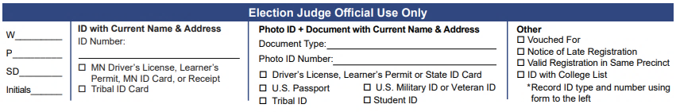

Tips for Completing Photo ID plus Document with Current Name and Address Column
If the voter presents an out-of-state ID, note which state it is on the ID number line.
Tips for Completing the Other Column
- Vouched For: Write “See Back” or “See Voucher Certificate”
- Valid registration in the same precinct: Write the voter’s ID number
- Notice of Late Registration: Write the voter’s ID number from the Notice or ID number “Not Available”
- ID with College List: Record the ID type and number using the column to the left

Using the Precinct Finder
- Find the voter’s street in alphanumeric order.
- Find the address range that fits the voter’s house number.
- Check if the range is odd (O), even (E), or both (B).
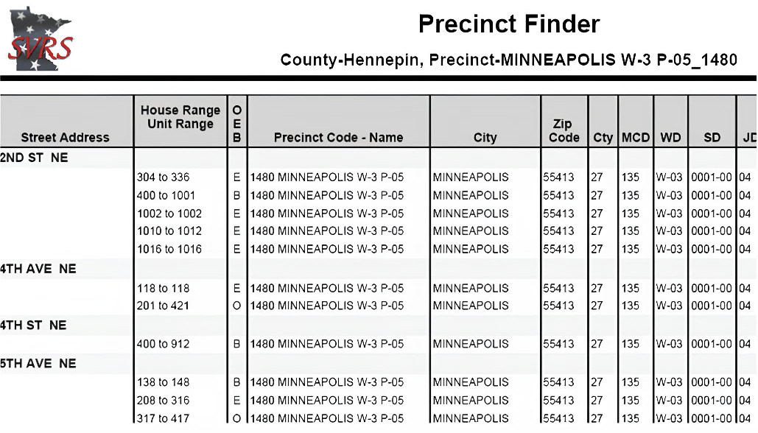
If the voter’s address cannot be located, use a map or the Polling Place Finder on mnvotes.gov to locate the correct precinct.
Note: Electronic rosters also have precinct finder information. Follow instructions for finding addresses using the electronic roster.

Determining Residence
A voter must live in the precinct where they are registering. Residence means the place a voter considers their true home—not just where they are staying for a short time. The law gives clear principles for deciding where a voter’s residence is:
General Rule
Residence is the home where a voter lives, intends to stay, and plans to return when away.
Temporary Absences
Voters do not lose their residence if they leave home temporarily for school, work, or travel, as long as they plan to return. Simply staying in a new place for a short time, without intending to make it home, does not create a new residence.
Moving to a New Place
A voter loses their old residence if they move to another precinct or state intending to make that their home, or if they file an affidavit of residence there to vote. If they move to another state for an indefinite time, they lose Minnesota residence even if they say they might come back someday.
Family Situations
Residence is usually where a voter’s family lives, unless the family is only there temporarily. If the family lives in one precinct but the voter sets up a separate home in another precinct and intends to stay there, the voter’s residence is at the new home.
Single Voters
For voters without family ties in the area, residence is where they usually live and sleep.

Special Cases
- Voters working temporarily in another precinct keep residence at their permanent home.
- Voters living permanently in a soldiers’ home or nursing home have residence at that facility.
- If a home crosses into more than one precinct, residence is in the precinct where most of the bedroom is located.
- If a home is destroyed or unlivable because of fire or natural disaster, a voter does not lose residence if they plan to return once it is repaired or rebuilt.
Intention and Action
Having the intent to move is not enough by itself to create residence. A voter must also actually move. Likewise, just moving is not enough unless the voter intends to stay in the new place. Minn. Stat. 200.031

Roster Data is Confidential
Election judges must not examine roster data except to assist the voter in front of them. Conceal challenge notations from other voters.

Address Confidentiality
Names and addresses of registrants are public unless the voter submits a signed safety statement to withhold their information. Attach this statement to the voter’s registration form.

Demonstration Judge
As Demonstration Judge, you instruct voters how to mark the ballot and how to deliver it to the ballot box. In most cases, the Demonstration Judge is also assigned to be the Ballot Judge.
Minn. Stat. 204C.16

Voter Instructions
- Vote only with the pen provided
- Fill in the target next to the candidate or question
- Place the ballot in the secrecy cover
  - Secrecy covers are to be available to voters, but are not required to be used
- Insert the ballot into the ballot counter or ask for help
- Request a replacement if you make a mistake
Minn. Stat. 204C.13

Additional Instructions for Primaries

Partisan Primaries
- No write-ins
- Vote only within one party’s column

Combined Partisan and Nonpartisan Primaries
- No write-ins
- Partisan offices: choose one party
- Nonpartisan: choose any

Presidential Nomination Primaries
- Ballot is specific to the party chosen
- May include “uncommitted”
- Write-ins are allowed only if chosen by the party chair

Additional General Election Instructions
- May vote for candidates from different parties
- May vote for up to the number allowed per office
- Write-ins are allowed if target is filled and name written
- No stickers on the ballot

Constitutional Amendment Instructions
Amendments include instructions on the ballot. Judges should not tell voters that not voting counts as a “no.” If asked, direct them to the printed instructions.

Ballot Question Instructions
Ballot questions have instructions on the ballot. If asked what “yes” or “no” means, direct voters to those instructions.

Special Elections
Your local election official will provide instructions for any special election.

Ballot Judge
As Ballot Judge, you count and track packs of ballots, collect registered voter receipts, and issue ballots. Always keep ballots secure and under control. Track ballot counts carefully—at the end of the day, you will need to reconcile the number of ballots originally sent to the precinct with the number of returned ballots. If you are unsure about a step, call your local election official.

Counting and Initialing Ballots
- Certify the total number of ballots provided to the precinct.
Count the number of ballot packets. They are typically wrapped in packets of 25, 50, or 100 ballots or another quantity listed on the package. Record the results on the form provided in your supplies.
- Confirm that your precinct’s ballots match the offices and candidates from the ballot counter.
If your polling place contains multiple precincts or has multiple ballot styles, prepare a supply for each style needed. Contact your local election official immediately if you have any concerns.
- Count ballots in each packet.
Packets may contain fewer or more ballots than listed such as 23 instead of 25. Carefully count each packet as they are opened during the day. Fan the ballots to ensure two are not stuck together. Record any discrepancies as +1 or -1 in the Incident Log or a Ballot Count form provided by the local election official.
- Initial each ballot.
Two judges must write their initials on each ballot before it is given to a voter. Be careful not to make any other marks. Any two judges may do this task.
- Open ballot packs only as needed.
Start with a modest supply and open more packets only as needed during the day. Store remaining ballots securely. Notify the Head Judge if the ballot supply becomes low. Do not issue the last ballot.
- Get out a supply of secrecy covers.
Secrecy covers are offered to voters to shield their ballot choices. Use is optional. If there are not enough covers, let voters know they can vote without one.
Minn. Stat. 204C.09, subd. 1

Ballot Shortages — Unofficial Ballots
- Contact your local election official if the ballot supply is running low.
- Keep one ballot to use for making unofficial ballots. Photocopy or reproduce it as needed, with permission from your local election official. Record how many were made on the Summary Statement.
Minn. Stat. 204B.30

Issuing Ballots
- Each ballot must bear the initials of two election judges.
- Only issue a ballot after collecting a valid voter receipt. Be sure to give the correct ballot style.
- Offer a secrecy cover if using a ballot counter.
- If you are also the Demonstration Judge, give ballot-marking instructions and direct the voter to a voting booth or ballot marking station. Only one person may be in a booth unless they request assistance.

- Remind voters taking an unusually long time that others are waiting. Two election judges from different major political parties must assist any voter who requests help.
- No one may take ballots from the polling place except judges assisting curbside voters.
Minn. Stat. 204C.13

Spoiled and Found Ballots
A spoiled ballot is one a voter returns because of an error. Give the voter a replacement ballot. Do not examine the spoiled ballot unless needed to identify the correct ballot style. If a ballot is abandoned in a booth, write “Found in booth” on it. These votes will not be counted. Place spoiled or found ballots in the Spoiled Ballot Envelope and record them in the Incident Log. Minn. Stat. 204C.13, Minn. Rule 8230.1050

Ballot Marking Device
Except for stand-alone township elections in townships with fewer than 500 registered voters, ballot-marking devices must be present in every polling place, so all voters have equal access. These devices provide privacy and independence to voters who cannot or choose not to use a pen.
They can:
- Display ballots in large print or high contrast
- Read the ballot aloud through headphones
- Allow selection by keypad, touchscreen, or sip-and-puff device
- Prevent errors like cross-party voting during primaries
- Print marked choices on a ballot or summary card
Important: Ballot marking devices do not count ballots. If a ballot is left in the machine, mark it “Found in Voting Station,” place it in the Spoiled Ballot Envelope, and record it in the Incident Log.

If helping a voter use the device, leave them in privacy once they begin marking choices. If they request help selecting candidates, two judges from different major political parties must assist.
Minn. Stat. 206.57, subd. 5
Types of Ballot Marking Devices
The AutoMARK, ExpressVote, OmniBallot, and Verity TouchWriter are stand-alone ballot marking devices. The ImageCast Evolution combines a ballot tabulator and marking device. Details vary; ask your Head Judge to review setup and instructions before polls open.

Ballot Counter Judge
As Ballot Counter Judge, you stay near the ballot counter to continually monitor and troubleshoot its operation and distribute I Voted stickers.

Guidelines for Conduct
- Unless they request help, voters insert their own ballot into the machine.
- No one, except for a voter casting their ballot or an election judge, is allowed within six feet of the ballot box. It is good practice to put tape on the floor to mark the six-foot boundary.
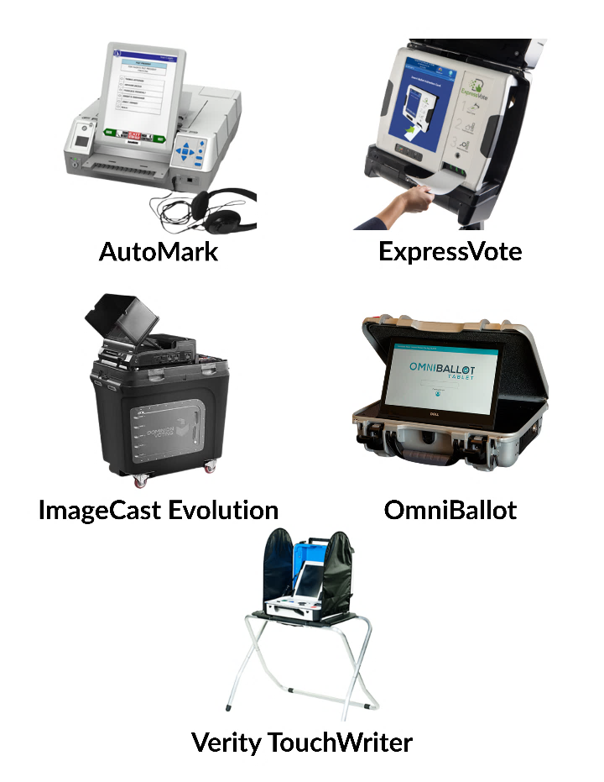

- The Ballot Counter Judge must be respectful of voter privacy and respect the six-foot boundary unless troubleshooting an issue or providing assistance at the ballot counter.
- Make sure that voters do not tamper with the equipment or the zeros tape while placing a ballot into the machine.
- After the voter finishes, offer an I Voted sticker. Offer the sticker rather than placing it on the voter.
Minn. Stat. 211B.11, Minn. Rule 8230.4365, subp. 3

Assisting with Ballot Errors
The ballot counter checks for ballot errors. If it locates an error, the machine will return the ballot. The tape or display will indicate the error. Here are common errors:
- Skewed ballot - Ballot counters should accept a ballot in any orientation, but rotating and re-inserting it in a different orientation can help. Have the voter turn the ballot around and reinsert it with both hands, keeping it straight.
- Overvoting - Overvoting is selecting more candidates for a single office than is allowed. For example, voters can only choose one candidate for U.S. president—voting for more than one presidential candidate is overvoting. In addition, the device may mistakenly identify stray pen or pencil marks as an overvote.
- Cross-party voting - In a partisan state primary, voters can only vote for candidates from one party. If they vote for candidates from more than one party, their ballot will be returned.
- Blank ballot - The machine will return a ballot if it is completely blank. A voter can cast a blank ballot if they choose.
Minn. Rule 8230.4365

Procedure for Resolving a Ballot Marking Error
- Check the ballot counter display or tape for the error message.
Do not inspect the voter’s ballot.
- Explain the error to the voter and offer the voter a replacement ballot.
If the voter does not understand your verbal explanation and asks for additional clarification, two judges from different major political parties may discretely review the ballot and advise the voter of the error.
- A voter may insist that the ballot be counted as is.
Explain to the voter that some or all their votes may not be counted. If the voter accepts this, the election judge or voter may use the override or accept button on the ballot counter to cause it to accept the ballot. Voters cannot vote again after their ballot is counted by the ballot counter. Minn. Rule 8230.4365

Full Ballot Box Procedure
- Two judges from different major political parties may open the ballot box to straighten or empty ballots and make room for more. When removing ballots, some precincts will need to separate ballots with write-in votes. Follow local official instructions regarding write-in ballots.
- In the Incident Log, record the time, initials of the judges present and the numbers from any seals used to secure the ballots in the transfer case(s). Local officials will provide additional instructions as needed.
Minn. Rule 8230.4365, subp. 5

Troubleshooting a Jammed Ballot
- If a ballot gets jammed in the ballot counter, ask the voter to remain in the polling place.
  - Read the error message on the ballot counter to see if the ballot got stuck before or after the machine counted it.
  - If ballot was not counted, an error message will indicate a problem ballot or instruct you to reinsert the ballot.
  - If the ballot was counted, an error message will instruct that the ballot be manually placed inside the ballot box.
- Remove the jammed ballot. If the ballot is visible, ask the voter to remove it. If not, slide the ballot counter forward and remove the ballot, or open the ballot box and remove it if necessary; then have the voter place the ballot in the secrecy cover.

  - If the ballot was counted, deposit it manually into the ballot box.
  - If the ballot was not counted, ask the voter to reinsert the ballot in a different orientation. If the ballot jams again, read the new error message, and have the voter place the ballot in the secrecy cover. Then accompany the voter to the Ballot Judge, ask for a replacement ballot and place the spoiled ballot in the appropriate envelope.
Minn. Stat. 206.57; Minn. Rule 8230.4365

If Voting Equipment Stops Working
If the ballot counter or other voting equipment stops working, have an election judge call your local election official and follow these instructions:
- Do not delay voting. Do not keep voters waiting while you try to fix the equipment. Open the auxiliary compartment slot of the ballot box so voters can deposit their ballot directly into the locked box.
- When the equipment is working again, two election judges must remove the ballots from the auxiliary compartment and feed them into the ballot counter. Minn. Stat. 206.57; Minn. Rule 8230.4365
- Explain to voters that once the ballot counter is operating, election judges will feed the ballots into the counter.
- Ballot-marking devices may still be used to help voters mark their ballots accurately. These devices prevent mistakes such as overvotes that would not be flagged by an inoperable ballot counter, in this case.

Election Day Health Care Facility Voting
In rare situations, election judges may deliver absentee ballots on Election Day. This only applies to voters who became a resident or patient in a health care facility or hospital the day before the election in the municipality where they live.
The voter must have requested an absentee ballot application from the local election official or county election office by 5:00 p.m. the day before the election.
Most voters in this situation choose agent delivery instead of election judge delivery.
Minn. Stat. 203B.11; Minn. Stat. 203B.04

Ballot Board Members and/or Early Voting Officials
Election Judges may serve as members of a county or municipal ballot board or as an Early Voting Official. If appointed to serve in either position, the county or municipal election official will provide information about hiring procedures and work schedules.
Minn. Stat. 203B.121; Minn. Stat. 203B.30

Rules for Polling Place Conduct

Rules for Polling Place Conduct

Who May Be in the Polling Place
During voting hours, only election judges, people directly engaged in voting, and authorized persons may be present in the polling place.

Authorized persons include:
- Persons assisting a voter
- Children accompanying a voter
- Vouchers
- Challengers appointed in writing by a political party or nonpartisan candidate
- Observers with written authorization from the Office of the Secretary of State, county auditor, or clerk
- Persons making a written complaint
- Media representatives (see Media section below)
- Teachers and students participating in a mock election authorized by the Secretary of State
- Sergeant-at-arms

Peace officers may only be present inside the polling place when they are:
- Voting
- Updating a registration or registering to vote
- Summoned by an election judge to restore the peace
Except in these situations, peace officers must not enter or remain in the polling place and must stay at least 50 feet from the entrance during voting hours.
If an unauthorized person is present, ask them to leave immediately.
No one in the polling place may discuss candidates or ballot issues. This includes voters waiting in line and election judges.
Minn. Stat. 204C.06, subd. 6; Minn. Stat. 204C.13, subd. 2; Minn. Stat. 211B.11

Campaign-Free Zone - Inside and Outside

Inside the Polling Place
Campaigning is prohibited inside the polling place at all times during voting hours.

Campaign material is not allowed inside the polling place. This includes:
- Clothing, buttons, or stickers
- Signs or literature
- Any item that promotes or opposes:
- A candidate on the ballot
- A ballot question on the ballot
- A political party represented by a candidate on the ballot
If a person is wearing or displaying campaign material:
- Ask them to remove or cover the item.
- If they refuse, still allow them to vote.
- Record their name and refusal in the Incident Log.
- Notify your local election official.
Voters may bring campaign materials or sample ballots into the voting booth to reference while voting, but they must not display them outside the booth.
Minn. Stat. 211B.11

100-Foot Boundary Outside the Polling Place
Campaigning is prohibited within 100 feet of the building containing the polling place during voting hours.
- If the polling place is located on public property, campaigning is prohibited anywhere on that property during voting hours, even beyond 100 feet.
- The 100-foot prohibition does not apply to adjacent private property.
If someone is campaigning within the restricted area:
- Inform them of the 100-foot boundary.
- Ask them to move outside the restricted zone.
- Document the interaction in the Incident Log.
- Contact the local election official if the person refuses.
Minn. Stat. 211B.11

Media in the Polling Place
Media representatives may observe voting but must follow these rules:
- Present photo ID and recognized media credentials (or written authorization from a local election official).
- Remain at least six feet from voters.
- Not speak to voters inside the polling place.
- Not interfere with the voting process.
- Not create lists of who is voting.
- Not record anything that reveals private voter information or ballot choices.
Media may take photos, video, or audio recordings if these rules are followed.

Additional Prohibited Conduct
The following is not allowed in the polling place or within 100 feet of the building:
- Disorderly conduct
- Smoking
- Lingering or gathering
- Intoxicated individuals
- Possession of liquor
If a person refuses to stop prohibited behavior:
- Ask them to leave.
- Notify the Head Judge.
- Contact your local election official if necessary.
- Document the incident.
Minn. Stat. 204C.06

Security Practices
Election judges are the first line of defense for the physical and cyber security of Minnesota’s elections. All election judges must:
- Keep watch over voting equipment, removable memory devices, ballots, and supplies throughout the day
- Immediately report and address anyone seen inspecting, tampering with, or trying to connect a device to voting equipment ports
- Regularly check seals and port plugs on voting equipment and ballot storage containers, reporting any concerns at once
- Report voter claims of suspicious activity (including email, text, social media, phone, or other threats or disruptions) to the local election official
Although uncommon, in an emergency, a sergeant-at-arms may be appointed to help maintain order and support election judges. Any event that may involve the removal of a person from a polling location should be reported to county or municipal election officials as it is happening or as soon as it is safely possible to do so.

Handling Disruptive Individuals in the Polling Place
If someone becomes disruptive or attempts to tamper with equipment, election judges may:
Warn the individual to stop and the Head Judge may escort them out of the area. If the behavior continues, the Head Judge can request assistance from a peace officer (law enforcement).
If law enforcement is called:
- Peace officers may enter the polling place to remove a disruptive person when summoned by an election judge to restore order
- Peace officers may also enter the polling place only when voting or registering to vote
- Peace officers and sergeants-at-arms must not otherwise interfere with voters
- Once peace is restored, peace officers must remain at least 50 feet from the entrance
Document all security concerns and how they were addressed on the incident log and report them immediately to the Head Judge for relay to the county or municipal election official.
Minn. Stat. 204C.06, subds. 5 and 6

Providing Assistance to Voters
Voters have a right to receive assistance from election judges or a person of their choice, except an agent of their employer or union. This could include assistance moving through the polling place, reading materials, completing forms, or marking ballots. An assistant is not required to be an eligible voter and can be younger than 18 years of age.

Assistance by Election Judges
- One election judge may provide assistance to voters, upon request, for most polling place activities such as mobility, re-reading ballot instructions at the demonstration station, etc.
- Two election judges of different major parties must assist a voter with marking their ballot but may do so for an unlimited number of voters in one election.
- Be sensitive to the specific needs of the voter. Avoid any action that may influence how they vote. Do not give advice or reveal how they voted. Direct questions to the voter, not to others with them. Help only as much as requested.

Assistance from Others
- The voter is not required to use election judges for assistance.
- An assistant of the voter’s choice, except an agent of their employer or union, may help the voter in all areas of the polling place, including in the voting booth.
- There are no longer limits on the number of voters a person may assist with marking ballots and candidates may serve as ballot marking assistants.
- If an assistant has marked a ballot on behalf of a voter, the voter may show it privately to an election judge to confirm that it is correctly marked before placing the ballot in the ballot box.
Minn. Stat. 204C.15, subd. 1

Curbside Voting
There may be instances where a voter is unable to enter the polling place. In this case, the voter can request that you bring a ballot out to their vehicle. Follow these procedures. The procedures are the same if a paper roster or electronic roster is being used.
Note: You cannot ask a voter why or if they qualify for curbside voting.
- Two judges from different major political parties go out to assist the voter. Ask and write down their name and return inside to check the roster and determine if the voter is registered.
- Bring a Certificate of Registered Voter form to each curbside voter. This form takes the place of signing the roster. If not registered, bring a registration application.
- Have the voter complete the form(s). Ask for proof of residence if they needed to register.

- Process forms. Give the Certificate to the Roster Judge if they were pre-registered or the Registration Judge if they needed to register in exchange for a voter receipt. Have the Roster or Registration Judge print curbside on the appropriate roster signature line. Attach the certificate to the page where the voter’s name appears on the roster. If electronic rosters are being used, follow instructions provided by local election official.
- Hand the receipt to the Ballot Judge for a ballot and bring it out to the voter.
- Have the voter fill out the ballot. Aid as needed.
- When voting is complete, tell the voter to remain until it’s communicated that the ballot was successfully counted.
- Place the ballot into the ballot box.
Keep in mind that if only one election judge remains in the polling place while other election judges administer curbside voting, that election judge may not approve an Election Day registration application and then provide a ballot to the same voter.
Minn. Stat. 204C.15, subd. 1

Serving Voters with Disabilities
Voters may encounter barriers at polling places, such as physical obstacles or staff who are not fully trained. As an election judge, your responsibility is to do what you can to make sure every voter can participate equally. Careful polling place setup is one of the most important steps for accessibility, and it is often where problems occur.
Always ask before offering help, respect privacy, and never touch a voter, their mobility aids, assistive devices, or service animals without permission. Many voters prefer to act independently.

Polling Place Accessibility on Election Day
Polling places must be set up so all voters can cast a ballot privately and independently. Accessibility includes the building itself and how judges arrange the space.
- Keep at least one entrance unlocked, clear, and wide enough for wheelchairs and mobility devices.
- Maintain clear pathways inside the polling place, free of barriers, cords, or furniture.
- Make sure the ballot marking device is powered on, tested, and ready to use throughout the day.
- Be prepared to provide curbside voting if a voter cannot enter the polling place.
If Problems Arise:
Report issues to the head judge right away. If they cannot be resolved, the head judge must notify the local elections official. Judges may move small barriers, but larger or structural issues should be escalated.
Important: Do what you can to make sure every voter can access the voting process. Quick problem-solving and timely communication with the head judge or local election official help ensure accessibility for all.

Voters Who Are Blind or Have Low Vision
Ask the voter how they would like to be guided. If you are both comfortable, offer your arm and describe the pathway, noting obstacles. Let them know if you are stepping away or handing off to another judge. Do not interact with guide dogs, as they must remain focused. At the roster table, provide tools such as a signature guide or magnifying glass.

Voters Who Are Deaf, Hard of Hearing, or Have Speech Disabilities
When possible, move to a well-lit, quiet area. Speak clearly and calmly, not louder. If the voter does not understand, rephrase instead of repeating. Gestures, visual aids, or written notes may help. For voters with both hearing and vision loss, use a bold black marker. Follow the voter’s lead if they use assistive technology.

Voters with Cognitive Impairments
Only a court can decide if a person is ineligible to vote due to incapacity. No one else, including family members or caregivers, can make that decision. Judges may not challenge a voter’s eligibility based on assumptions. Voters retain their right to vote even under guardianship, conservatorship, or power of attorney, unless a court order specifically removes it.

Contesting a Voter’s Eligibility
An election judge, any eligible voter in the precinct or an appointed challenger may contest a voter’s eligibility, if they have personal knowledge that the person is not eligible to vote.
Important: Suspicion is not a basis for making a challenge; the challenger must personally know that a specific person is not eligible to vote for a specific reason. Minn. Stat. 204C.07

Appointed Challengers
Major political parties and/or nonpartisan candidates can appoint one challenger per precinct, who may remain in the polling place for the day. Challengers are not poll watchers; the only action a challenger may take is to contest a voter’s eligibility, if and only if they have personal knowledge of that voter’s ineligibility. If this happens, a judge will follow the procedure below.
If you have doubts about whether the challenger should be present, ask to see their credentials or check with your local election official. You have a right to eject a challenger who violates these provisions after being asked to cease any prohibited activity.
All challengers must:
- Present the Head Judge their written appointment from a political party or a nonpartisan candidate. Appointments cannot be made by partisan candidates. Appointments must be made in writing.
- Prove their Minnesota residence by presenting one of the proofs of residence accepted for Election Day registration. Challengers are not required to prove residence in the precinct where they are appointed.
Minn. Stat. 204C.07

Code of Conduct for Appointed Challengers
- A challenger can only challenge a voter’s eligibility based upon their personal knowledge that the voter is not eligible to vote there.
- A challenger cannot speak to the voter and should only speak to the judge when initiating a challenge. All challenges must be made in writing.
- Challengers cannot be disruptive, handle or inspect voter registration applications, files, or lists.
- They cannot make lists of who did or did not vote.
- Challengers cannot take photos within the polling place.
- Challengers cannot go within six feet of the ballot counter.
- Challengers cannot attempt to influence voting.
Note: Challengers cannot compile lists of voters to challenge based on mail sent by a political party that was returned as undeliverable or if receipt by the intended recipient was not acknowledged in the case of registered mail.
Minn. Stat. 204C.07

Procedure for Making and Resolving a Challenge
If a voter’s eligibility is contested by a challenger, an election judge, or any other voter, you or another designated judge must resolve the challenge in this manner:

Step 1: Complete the challenge form
- Have the challenger fill out the Oath of Challenge to Voter’s Eligibility form.
- The challenger must state the basis of the challenge in writing.
- A challenger may only speak to the election judge — they may not speak directly to voters.
Step 2: Administer the oath to the voter
Ask the challenged voter to swear or affirm:
“Do you solemnly swear (or affirm) that you will fully and truly answer all questions put to you concerning your eligibility to vote at this election?”

Step 3: Question the voter
Ask the voter questions related to the reason for the challenge. Examples include:
- What is your full name?
- What is your residential address?
- Are you at least 18 years of age?
- Are you a citizen of the United States?
- Are you under a court-ordered guardianship in which the court has revoked your right to vote, or found by a court to be legally incompetent?
- Have you been recently released from incarceration for a felony sentence?

Step 4: Decide based on the answers
- If the voter’s answers indicate they are eligible, allow them to sign the roster (or follow electronic roster instructions).
- If the challenger persists, have the voter repeat the oath again aloud at the top of the roster. After signing, the voter must be allowed to vote.

Step 5: Record the outcome
- Make notations on the Oath of Challenge to Voter’s Eligibility form and the Incident Log as appropriate.
- Inform the challenger they may contact the county attorney to pursue the matter further.
Minn. Stat. 204C.12

Refusing or Failing a Challenge
If a voter refuses to answer questions, is not eligible, or refuses to sign the roster, inform them that they cannot vote now or later in the day. Print “Refused Oath” or “Not Eligible” on the appropriate roster signature line and make a note in the Incident Log. Follow instructions if electronic rosters are used.
After resolving the challenge, continue normal polling place operations. Remind all judges to maintain professionalism and avoid discussing the incident with other voters. If the situation escalates or if there are safety concerns, contact your local election official immediately for further instructions.

Voter Complaints

HAVA Complaints
The HAVA Complaint Form must be available to voters upon request during federal elections. It can be used if a person believes a violation of the Help America Vote Act (HAVA) Title III such as voting machine standards, posting of voting information, or voter registration has occurred, is occurring, or is about to occur.
It is not for:
- Minnesota Fair Campaign Practice & Finance Acts complaints listed in Minn. Chapters 211A and 211B
- Other Minnesota election law complaints use the State Election Law Complaint Form instead
Instruct the voter to complete the form, sign it, and have it signed by an election judge or notary. Voters may complete it at the polling place or take it with them. Election judges may sign as a notary on Election Day because this only verifies witnessing the signature, not agreement with the complaint. Record the event in the Incident Log. Instruct the voter to deliver the form to the address listed on it.
Note: For more information about submitting complaints visit our webpage about Election Law Complaints (https://www.sos.mn.gov/elections-voting/secure-and-fair-elections/election-law-complaints/)

State Election Law Complaints
The State Election Law Complaint Form may be used if a person believes a violation of Minnesota election law has occurred, is occurring, or is about to occur as per Minn. Chapters 200, 201, 203B, 204C, or 206. It is not for complaints about Minn. Chapters 211A or 211B that are referred to the Office of Administrative Hearings.
This form must be completed, notarized, and returned to the county attorney for investigation. Record the event in the Incident Log. Minn. Stat. 200.04
Note: For more information about submitting complaints visit our webpage about Election Law Complaints (https://www.sos.mn.gov/elections-voting/secure-and-fair-elections/election-law-complaints/)

Closing Polls Procedures

Closing the Polls Overview
- At 8:00 p.m., announce: “The polls are closed.” Everyone already in line may still vote, including those waiting to register. Anyone arriving after 8:00 p.m. cannot vote. Mark the last voter with a card or have a judge stand behind them.
- Do not take down materials or equipment until the last voter finishes. Remove the U.S. flag from outside.
- Do not lock the polling place doors. The public may watch closing tasks and view vote totals, but they cannot interfere or give extra instructions.
- Follow your local election official’s instructions for closing tasks, which usually include:
  - Counting voted ballots or preparing them for transport
  - Completing the precinct Summary Statement and reports
  - Packing up voting stations, ballot counter, ballot marking device, posters, and supplies
Minn. Stat. 204C.20

Keeping Ballots and Equipment Secure
- The public may watch closing, but they cannot:
  - Handle ballots, materials, or equipment
  - Access ballot counters, ballot markers, or program devices
  - Stop judges from following official instructions
- A sergeant-at-arms or peace officer may be present for safety.
- Once final counts match, immediately prepare the summary statement and seal the ballots.

Closing Activities Based on Counting Method
Your steps depend on the ballot counting method your precinct uses. Your local election official decides this ahead of time.

Closing with a Precinct Ballot Counter

Summary Statement and Results Tape
- The Summary Statement lists your precinct’s results. The ballot counter prints a results tape with the same data.
- Use the results tape, rosters, and Incident Log to complete the Summary Statement. In some precincts, the results tape itself is the Summary Statement.
Minn. Stat. 204C.24

Closing Steps
- Process ballots in the auxiliary compartment. Two judges from different major parties remove these and feed them into the counter.
- Print at least three copies of the results tape or two if not a state election. Post one publicly. Tell observers totals don’t include absentee votes.
- If instructed, count write-in votes and record them on the Write-in Tally Sheet.
- Complete the Summary Statement.
- Seal voted ballots in envelopes/containers and have all judges sign across the seals.
- Pack up the ballot counter and return all materials as instructed. One judge may deliver them if all ballots are sealed.
Minn. Rule 8230.4365

Completing the Summary Statement
- Make sure the number of ballots counted equals the number of signatures or receipts.
- Do not count lines marked “A.B.”, “M.B.” or “E.V.” as signatures. Call your local election official if totals do not match.
Include these numbers:
- Ballots cast (signatures or receipts)
- Registered at 7:00 a.m. found on the last page of a paper roster – follow instructions for electronic rosters
- New registrants on Election Day
- Ballots delivered to the precinct
  - Ballot count adjustments (+/-) from opened packs
  - Clerk-certified number of ballots delivered
  - Number of unofficial ballots made
- Ballots not in the ballot box
  - Spoiled ballots
  - Original ballots for which duplicates were made
  - Unused ballots
- Number of election judges and voting booths
- Number of voted ballots showing only voter’s choices (if your equipment records this)

Duplicating Ballots
If a ballot is damaged, unreadable, or rejected by the counter, two judges from different major parties must make a duplicate:
- Label pairs as “original 1” and “duplicate 1” and number all sets.
- Note the reason for duplication on the duplicate ballot.
- One judge reads the votes, the other marks the duplicate.
- Resolve voter intent issues using the rules in this guide.
- Both judges initial and compare the ballots to confirm accuracy.
- Insert the duplicate into the ballot counter.
- Place the original in the envelope marked “Original Ballots for which Duplicates have been Made.” Record the number and seal the envelope.
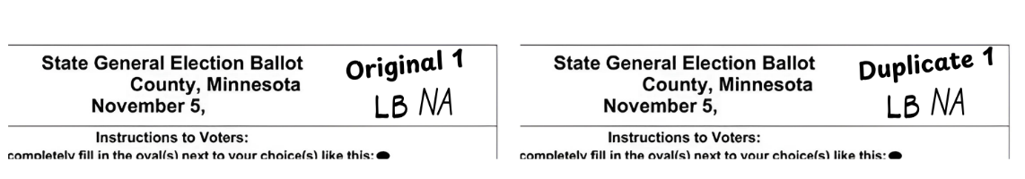
Minn. Stat. 206.86, subd. 5, Minn. Rule 8230.3850

Delivering Election Supplies and Ballots
As soon as possible, deliver these to your local election official:
- Results tapes and Summary Statements
- Sealed containers with voted ballots
- Sealed spoiled ballot envelope
- Sealed envelope of original ballots for which duplicates were made
- Rosters - pre-registered and Election Day
- Completed voter registration applications
- Any other materials required by your local election official
Minn. Stat. 204C.27
Important: Follow your jurisdiction’s chain of custody plan carefully. If you have questions, or if you cannot follow the plan as written, contact the local election official immediately.

Closing with a Central Ballot Count
Local election officials decide before Election Day whether your precinct uses central ballot counting. Judges cannot change this.
Judges must prepare at least three Summary Statements for state elections and at least two for other elections.

At the Polling Place
After the last voter casts a ballot, record the following:

Ballot Counts
- Total ballots delivered adjusted for any discrepancies in the Incident Log
- Unofficial ballots if any
- Spoiled ballots
- Unused ballots
- Total ballots being returned
- Write-in votes if instructed

Roster and Registration Counts
- Number registered at 7:00 a.m. from the back of the paper pre-registered roster – follow instructions for electronic rosters
- Number who registered on Election Day by counting signatures or forms
- Total signatures on all rosters or voter receipts - do not count A.B., M.B. or E.V. notations
Seal the ballots in the container and sign the certification. At least two judges from different major parties must deliver the ballots and forms to the courthouse or counting center.
Minn. Rule 8230.2250

At the Counting Center
Judges either hand off ballots to another team or stay to help with counting. Judges there certify results and complete the Summary Statement.

Counting Steps
  - Verify and break the seal on the ballot container.
  - Run ballots through the counter (use batches for large precincts).
  - Duplicate any damaged ballots (if instructed).
  - Count write-in votes (if instructed) and record them on the Write-In Tally Sheet.
  - Print the Summary Statement totals.
  - Compare totals to the number of ballots and voters. Resolve any differences.
  - Seal ballots and sign the seal or certificate.

Election Returns and Supplies
Deliver to your local election official:
- Summary Statements or counter tapes
- All voted ballots in sealed containers
- Spoiled ballot envelope
- Envelope of original ballots for which duplicates were made
- Rosters
- Completed registration forms
- Pre-Registered and Election Day Registration Rosters
- Other required materials
Minn. Stat. 204C.27

Hand-Count Precincts
In hand-counted precincts, judges count ballots by hand. Local election officials decide this before Election Day.

Before Voting
- Lock the ballot box and give the key to another judge.
- A numbered seal may be used instead of a lock.
Minn. Stat. 204C.19, subds. 1 & 2, Minn. Stat. 204B.22, subd. 2

After Voting
- Start counting immediately after the last voter finishes.
- Continue without interruption except for short breaks.
- Only election judges may handle ballots and materials.
- Counting teams must be evenly split between major parties.
While Counting
- Complete the Summary Statement as you go.
- Count the ballots per box, total ballots, and total votes.
- Follow rules for determining voter intent.

Summary Statements
- Complete at least three copies for state elections.
- Ensure accuracy: include precinct, city/town, date, election type, and all offices/candidates.
Minn. Stat. 204C.26, subd. 2

State Primary
- Separate parts for each party and for nonpartisan races.
- No write-in votes allowed.

State General Election
- Record votes for registered write-in candidates if the target is filled in.
- Local election officials will direct whether to tally local write-ins.

Counting the Ballots
  - Remove all ballots from the box.
  - If two ballots are folded together, set them aside until the end.
  - Count ballots in stacks of 25 and total them.
Minn. Stat. 204C.19, subd. 2, Minn. Stat. 204C.20, subd. 1

Ballot Accounting
- Voters who voted + spoiled ballots + unused ballots = ballots issued.
- Ballots in the box must not exceed the number of voters.

Excess Ballots
- Remove pairs stuck together.
- Remove ballots missing judge initials.
- If still too many, randomly remove ballots until totals match voters.
- Seal set-aside ballots with an explanatory note.
Minn. Stat. 204C.20, subds. 1 through 4

Determining Voter Intent
Election judges should do everything possible to count a ballot if the voter’s choices can be understood. Only the face of the ballot may be used to determine intent.
  - Ballot valid if intent is clear
Do not reject a ballot for small technical mistakes if you can still tell what the voter meant.
  - Look only at the ballot
Judge intent based only on what appears on the ballot itself.
  - Too many votes for an office
- If a voter selects more candidates than allowed for an office, no vote is counted for that office. The rest of the ballot still counts.
- In a primary, if a voter marks candidates from more than one party and has not indicated a party preference, the entire partisan portion of the ballot is invalid.
- If a party preference is indicated, only that party’s votes count.
  - Voting yes and no on a question
If both Yes and No are marked, no vote is counted for that question. The rest of the ballot still counts.
  - Write-in in the correct place
A name written in the correct write-in space counts, even if the oval is not filled in.
  - Write-in for governor only
A write-in vote for governor counts for the full team - governor and lieutenant governor.
  - Write-in on a primary ballot
Writing in a name on a primary ballot does not count as a vote.
  - Mark out of place
If a mark is slightly outside the oval but clearly shows intent, the vote counts.
  - Counting up to the limit
- Judges count only up to the number of candidates allowed.
- If fewer are chosen, only those votes count.
- If too many are chosen, no votes count for that office.
  - Misspelling or abbreviations
If the name is clear despite misspelling or abbreviation, the vote counts.
  - Partial ballot choices
If only some choices on a ballot are clear, count those and disregard the rest.
  - Different marks
- If a voter uses a consistent mark (like a check or X), count it.
- If the voter uses different marks but intent is clear, count them.
- If marks appear to identify the ballot, the whole ballot is defective.
  - Erasures
If two candidates were marked but one mark was erased, count the remaining candidate.
  - Soiled or damaged ballots
Do not reject a ballot just because it is dirty or slightly damaged.
  - Identifying marks
If a ballot has marks that appear to identify the voter, the whole ballot is invalid.
  - No votes marked for an office
If no candidate is chosen for an office, no vote is counted for that office.
  - Blank for one or more offices
A ballot with blanks for some offices or questions is still valid. Only the unmarked parts are blank.

Defective Ballots
A ballot is defective if voter intent cannot be determined or if it was identified by a name, number, or signature. Mark “Defective” and keep with other voted ballots. Record totals on the Summary Statement.
Minn. Stat. 204C.22 through 204C.24

Counting Votes
- Sort by candidate including write-ins and by undervotes/overvotes.
- Count each pile in stacks of 25.
- Repeat for each office or question.

Completing the Summary Statement
Include: ballots delivered, unofficial/spoiled/unused ballots, registered voters at 7:00 a.m., Election Day registrants, roster signatures, and total ballots returned. Place a signed copy in each envelope and seal.
Minn. Stat. 204C.26, subd. 2

Delivering Election Returns
Deliver to local officials as soon as possible:
- Summary Statements
- All voted ballots in sealed containers
- Spoiled ballot envelope
- Rosters
- Registration forms and rosters
- Other required materials
Minn. Stat. 204C.27
Important: Follow your jurisdiction’s chain of custody plan carefully. If you have questions, or if you cannot follow the plan as written, contact the local election official immediately.

Head Judge
The Head Judge is the lead election official in the polling place and has completed one additional hour of required training for handling some of the more complex duties. You oversee the polling place, assign judges to specific tasks, and give others direction as needed.
You also:
- Pick up the precinct supplies before the election
- Ensure supplies are ready before opening
- Oversee polling place setup
- Administer the election judge oath
- Conduct emergency judge training for replacement judges (see below)
- Resolve questions and problems during Election Day
- Complete election returns and other forms
- Close the polling place and return materials
Minn. Stat. 204B.20; Minn. Rule 8240.1750

Emergency Preparedness
As Head Judge, you are responsible for leading the polling place through any emergency, such as fire, severe weather, or other threats. Your first priority is the safety of yourself and those around you. Stay calm, give clear instructions, and set the tone for others.
- Establish control. Take charge of the situation, announce the emergency, and guide next steps.
- Prioritize safety. Direct voters and judges to safe areas or exits before worrying about election materials.
- Use the plan. Be familiar with the building’s emergency and evacuation procedures. Lead people calmly and clearly to exits.
- Delegate tasks. Assign other judges to assist voters, maintain order, or help those with mobility needs.
- Preserve election materials when safe. If conditions allow, secure voter records, ballots, and the ballot counter, but never at the risk of personal safety.
- Communicate with officials. Once safe, contact your local election official for instructions on whether voting will continue or move to a new location.
- Reassure voters. Maintain professionalism and provide updates, reminding voters that every effort will be made to continue the election securely.

Change of Polling Place
Contact your local election official if your polling place is unusable and you must move to a new polling place. Upon their approval, a location may be used which is as near as possible to the original polling place.
- Publicly announce the change to the voters present and post a notice in a location visible by voters from their motor vehicles.
- Post a similar notice of the change in the new polling place.
Minn. Stat. 204B.17

Replacing an Absent Judge
Head election judges are responsible for training replacement election judges appointed on Election Day. Head Judges should follow the emergency training checklist provided by the local election official to conduct this training.
Minn. Stat. 204B.23

Emergency Voting Procedure
If a voter’s name was mistakenly left off the roster and the person refuses or is unable to complete the Election Day registration procedure, follow this emergency voting procedure:
- Contact the county auditor to confirm the person is registered
- If the auditor confirms the registration and authorizes next steps, have the voter print the required name and address information on the roster page where the voter would have been listed alphabetically
- Two judges note on the roster that the voter was permitted to vote pursuant to instructions from the county auditor
- Two judges initial the voter’s entry on the roster
- Give the voter a receipt and direct the voter to the Demonstration or Ballot Judge
- Make a note in the Incident Log
Minn. Rule 8200.3800

Incident Log
- Instruct all judges to record any unusual events or problems in the Incident Log
- Examples: ballot counter stops operating, a disturbance occurs, a voter’s name is missing from the roster, or a voter is upset about something that happened
- Record the event, the time it occurred, and the resolution
- The Incident Log helps solve problems at the end of the day
  - Examples include the number of ballots cast and signatures on the roster don’t match
- Include as much detail as possible in case further investigation is needed
- Return the Incident Log to your local election official with the other precinct supplies
The following events and information must be recorded in the Incident Log if they occur:
- Discrepancies in ballot counts Minn. Stat. 204C.09
- Ballots found in voting station Minn. Rule 8230.1050
- Facts surrounding excess ballots Minn. Rule 8230.2030
- Opening a ballot box during voting hours Minn. Rule 8230.4365
- Irregularities or discrepancies with the ballot counter seal Minn. Rule 8230.4365

Absentee, Mail Ballot and Early Voting Ballots
The roster notation “A.B.”, “M.B.” or “E.V.” next to a voter’s name indicates the voter has cast an absentee, mail ballot or early voting ballot and cannot vote in the polling place. Your local election official may provide you with a supplemental list of voters who voted by either type of ballot after the rosters were printed. Print “A.B.”, “M.B.” or “E.V.” on the appropriate signature line of the paper roster for voters that appear on this list. Follow instructions for electronic rosters.
Your local election official may also contact you on Election Day to determine whether voters whose absentee ballots were received have already voted in person. You may be asked by phone to immediately print “A.B.”. “M.B.” or “E.V.” on the appropriate signature line so these ballots may be accepted and counted. Alternatively, you may receive an updated supplemental list and be asked to confirm with your election official when the appropriate signature lines have been marked. Follow instructions for electronic rosters.
Minn. Stat. 203B.121

Health Care Facility Judges
Health care facility judges must complete an extra hour of training to be certified for this role. These judges conduct absentee voting for eligible voters who are temporary or permanent residents or patients in a health care facility or hospital located in the municipality where they live and who have submitted an absentee ballot application. Eligible voters may register or update their registration as part of the absentee voting process.
If a voter registers using a voucher at a health care facility, the same vouching rules apply as on Election Day. A staff person who vouches must provide proof that they are employed by and working in the residential facility and have personal knowledge the voter is a resident of the precinct. An election judge may sign a proof-of-residence oath only if the judge personally knows the voter is a resident of the precinct. Minn. Stat. 201.061, subd. 3(a)(4)
Ballots must be delivered by two or more judges from different major political parties. Judges must travel together in the same vehicle when delivering or returning ballots.
Both judges must be present while the voter completes the eligibility certificate. The voter must be allowed to mark the ballot privately unless they request assistance.
Important: Do not deviate from your jurisdiction’s chain of custody plan. If you cannot follow the plan as written, contact the official in charge immediately. Ballots must always remain under the control of the judges and must never be left unattended.
The voter has the option to:
- Mark their own ballot
- Ask the health care facility judges for assistance
- Ask another person who is not their employer or union representative for assistance
- There is no limit to how many voters the health care facility judges may assist, as long as the voter gives consent
Health care facility outreach voting occurs during the 35 days before an election.

Helpful Links and Resources

Minnesota Secretary of State Website Resources
Use these resources if you need quick answers or to assist voters on Election Day.

Election Day Forms
(https://www.sos.mn.gov/election-administration-campaigns/election-administration/election-day-forms/)
Access official forms used in polling places, such as the Oath of Challenge, Certificates of Registered Voter, Summary Statements, and complaint forms. If you run out of a form or need to confirm what to use, you can find it here.

Poll Finder
(https://pollfinder.sos.mn.gov/)
Look up a voter’s correct polling place and its hours. If a voter is in the wrong location, you can quickly give them accurate directions.

Voter Status Check (MN Votes)
(https://mnvotes.sos.mn.gov/voterstatuscheck/index)
Confirm whether a voter is registered in Minnesota. This helps resolve registration questions and prevents delays at the polling place.

Head Judge Duties Checklist

Opening
☐ All judges report to assigned precinct one hour prior to voting start time. Generally, voting hours begin at 7:00 a.m., but may differ. Call your local election official if all judges have not arrived. Request assignment of replacement judge(s).
☐ All judges take the judge oath, sign the Judge Oath Form, and receive badges.
☐ Assign judges to set up the polling place, post posters and signs, and post the U.S. flag outside.
☐ Assign judge duties (Greeter, Roster, Registration, Demonstration, Ballot, Ballot Counter) and give directions.
☐ If you received a list of absentee, mail ballot or early voters, mark “A.B.”, “M.B.” or “E.V.” on the roster.
☐ If you received a list of Election Day registration absentee voters, provide it to the Roster Judge.

Ballot Preparation
☐ Two judges check ballots against the official certification form to confirm they are the correct precinct.
☐ Certify the correct number of ballots delivered; count ballot packs.
☐ Two judges open ballot packs, count ballots, record discrepancies in the Incident Log, and initial ballots.
☐ Place ballots in view of judges in a secure area.

Ballot Box Opening
☐ Open all ballot box doors, remove contents, have all judges confirm the box is empty, then relock or seal.
☐ Confirm any auxiliary ballot boxes are empty.
☐ Connect to power source and check that it is working.
☐ Keep auxiliary slot closed when not in use.

Ballot Counter and Ballot Marking Station Setup
☐ Place ballot counter on the ballot box.
☐ Two judges check the seal number against the certification form, complete and sign.
☐ Plug ballot counter into outlet; confirm power is working.
☐ Run the zero tape.
☐ Check that precinct number matches your precinct.
☐ Compare an actual ballot to the tape output to confirm rotation.
☐ Confirm vote total column reads “0000.”
☐ Secure the zero tape as one continuous tape. Ensure it cannot be torn or tampered with.
☐ Set up the ballot marking station in an accessible, private location, away from the ballot counter.
☐ Verify the ballot marking device displays correct information for the precinct.

Open Polls
☐ Judges begin their assigned duties.
☐ Announce the poll is open at the assigned time.
☐ If the ballot counter is not operating, use the auxiliary ballot box for ballots until it is working.

Close Polls
☐ Announce the poll is closed at 8:00 p.m. Voters in line at 8:00 p.m. are allowed to vote.
☐ After the last voter has voted, allow the public to view the closing process.

Closing with a Ballot Counter
☐ Inspect and confirm seals on the ballot counter.
☐ Print required number of sets of tapes per local election official instructions.
☐ Complete all blank lines on the Summary Statement on the tapes and any additional forms provided.
☐ If total voters do not equal votes cast, contact your local election official.
☐ If ballot counter has a modem, transmit results to headquarters.
☐ All judges sign all tapes.
☐ Place all tapes with election materials for return.
☐ Turn off and unplug ballot counter.
☐ Cut seal on the ballot counter, remove memory card, and place in protective cover or bag.
☐ Place the memory card with materials for return.
☐ At least one judge returns materials as directed by the local election official.

Central Count Closing Procedures
☐ Reseal ballots in the ballot box and sign certification.
☐ At least two judges from different major political parties deliver the ballot box and Summary Statements to the central count location.

Hand-Count Closing Procedures
☐ At least two judges from different major political parties remove all ballots from the box.
☐ Ensure election judges follow instructions for hand counting ballots found in this Hand-Count Precincts section of this guide.
☐ At least one judge returns materials as directed by the local election official.

Voter’s Bill of Rights
For all persons residing in this state who meet federal voting eligibility requirements:
(1) You have the right to be absent from work for the purpose of voting in a state, federal, or regularly scheduled election without reduction to your pay, personal leave, or vacation time on election day for the time necessary to appear at your polling place, cast a ballot, and return to work.
(2) If you are in line at your polling place any time before 8:00 p.m., you have the right to vote.
(3) If you can provide the required proof of residence, you have the right to register to vote and to vote on election day.
(4) If you are unable to sign your name, you have the right to orally confirm your identity with an election judge and to direct another person to sign your name for you.
(5) You have the right to request special assistance when voting.
(6) If you need assistance, you may be accompanied into the voting booth by a person of your choice, except by an agent of your employer or union.
(7) You have the right to bring your minor children into the polling place and into the voting booth with you.
(8) You have the right to vote if you are not currently incarcerated for conviction of a felony offense.
(9) If you are under a guardianship, you have the right to vote, unless the court order revokes your right to vote.
(10) You have the right to vote without anyone in the polling place trying to influence your vote.
(11) If you make a mistake or spoil your ballot before it is submitted, you have the right to receive a replacement ballot and vote.
(12) You have the right to file a written complaint at your polling place if you are dissatisfied with the way an election is being run.
(13) You have the right to take a sample ballot into the voting booth with you.
(14) You have the right to take a copy of this Voter's Bill of Rights into the voting booth with you."

Guide for Registration Application

Required Sections
  - Qualifications Check Boxes—voter checks the box whether they are a U.S. Citizen, and they are at least 16 years old and will be at least 18 years old on or before the day of the election in which they intend to vote.
  - Voter Name—voters give their last name or surname, first name, middle name, and suffix (if suffix applies).
  - Home Address—voters print the street address or a geographical description of where they live. An example of a geographic address is Highway 47, ½ mile north of County Road E. A business address may not be used unless it is also the voter’s home. Neither a U.S. Post Office Box, nor its commercial equivalent may be used as a residential address.
  - Date of Birth—voters give their complete date of birth.
  - Identification Check Boxes— voters check the box that applies to them and fill in the respective ID number. If the voter does not have a MN-issued driver’s license, a MN-issued ID card, or a Social Security number, they check the third box.
  - Oath, Signature and Date—be sure to tell voters to read the oath on the application and sign only if all parts apply to them. By signing, they affirm that all the statements on the application are true and correct and that they meet the requirements in the certification. Giving false information to register to vote is a felony punishable by up to 5 years in prison and/or a fine up to $10,000.

Complete if Applicable/Possible
  - Mailing Address—give a mailing address (such as a PO Box) only when the U.S. Post Office will not deliver mail to the voter’s actual street or geographical address. Other mailing addresses such as workplace addresses cannot be used. If a voter chooses to use a PO Box, it cannot be listed.
  - Line Phone Number—encourage voters to list their phone number so they can be contacted if there is difficulty in processing the application, although it is okay if they do not.
  - School District and County—if voters are sure of their school district, have them indicate the district number or name; otherwise leave blank. If there is a school district election on the ballot, use the precinct finder to verify the voter’s school district.
  - Email Address—voters may provide their email address, although it is acceptable if they do not.

Registration Updates
If a voter’s name or address has changed, they must update their voter registration on Election Day.
To update their record, the voter must complete a voter registration application form. This is required even if the voter moved within the same apartment building or only changed apartment units.
The voter should provide their previous name and/or address so their existing voter record can be located and updated.
Important: If the voter was previously registered in the same precinct under a different name or address, no additional proof of residence is required.

Important Contact Information

Clerk’s Office______________________________________________________________________
County Auditor’s Office ___________________________________________________________
Voting Machine Repair____________________________________________________________
County Sheriff / Local Police_______________________________________________________
Fire Department__________________________________________________________________
Emergency Medical Services ________________________________________________________
Minnesota Election Judge Guide Last Updated
May 2026

